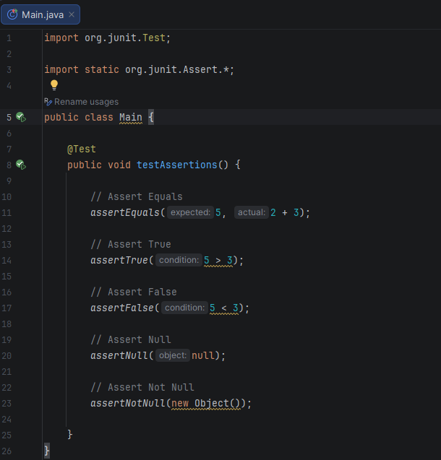

BUILD SUCCESSFUL:
